Vending Machine Programming Report

Introduction
This project focuses on the design and development of a Vending Machine System created using C# within the Windows Forms Application (WinForms) framework. The main objective of this project is to replicate the functionality and overall user experience of a real-world vending machine by providing an interactive and user-friendly graphical user interface (GUI). Through this system, users can interact with a virtual vending environment where they are able to select products, insert virtual coins and banknotes, and automatically receive the correct amount of change according to their transaction.
To enhance realism and interactivity, the application incorporates a drag-and-drop feature, which allows users to manually drag coins into the coin slot and notes into the note slot, like how a physical vending machine operates. This approach not only improves user engagement but also demonstrates the practical application of event-driven programming techniques in C#. By responding to user actions and events in real time, the system effectively illustrates how interactive applications can be designed and implemented using the WinForms framework.
In addition, this project emphasizes the integration of user interface design principles, transaction processing, and logical computation to manage various payment scenarios, product selections, and balance calculations. The system provides accurate and dynamic feedback to users through graphical updates and automated change dispensing, ensuring a smooth and realistic experience.
Overall, the Vending Machine System serves as a practical demonstration of how C# WinForms can be utilized to develop interactive applications that combine functionality, usability, and visual appeal. The project not only simulates the core operations of a real vending machine but also highlights important software engineering concepts such as modularity, usability, and logical control flow, which are essential in modern application development.

Design
Vending Machine Interface – Detailed Description
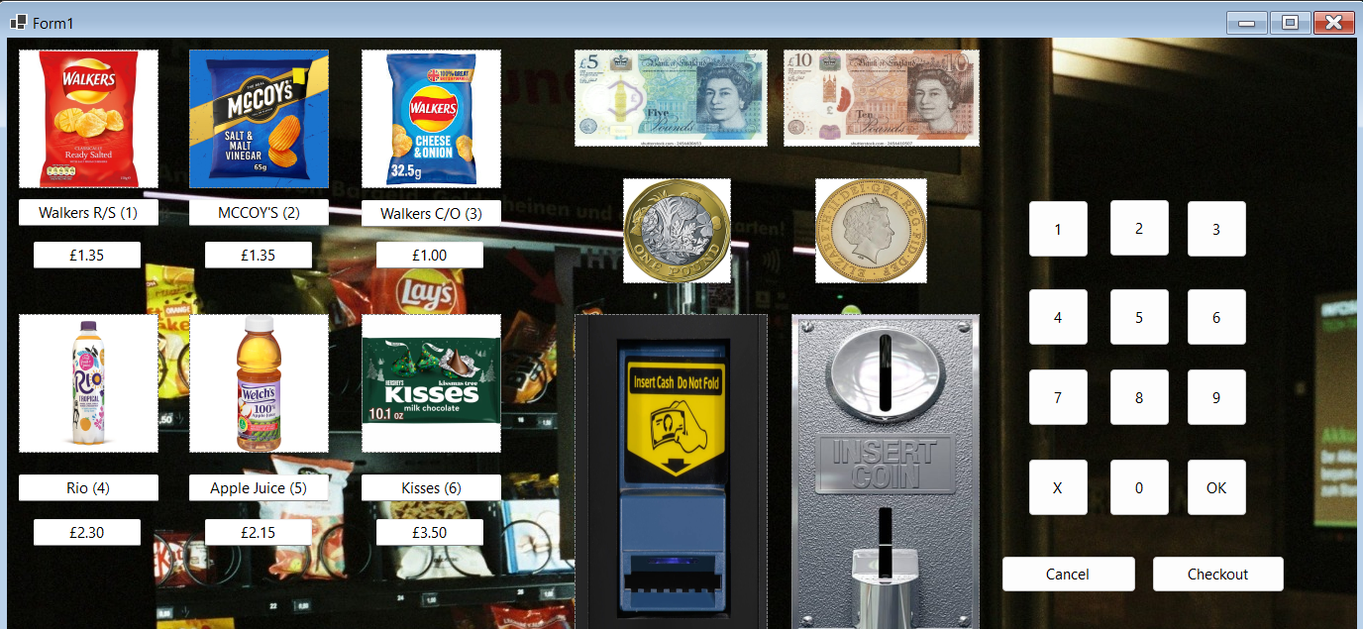
(Figure 1.0)
The vending machine interface design shown in the image is a graphical representation of how a user interacts with an automated vending system. At the top section, six different products are displayed, each accompanied by an image, a label, and its respective price. The available items include Walkers Ready Salted crisps (item code 1) priced at £1.35, McCoy’s Salt & Malt Vinegar crisps (item code 2) also priced at £1.35, Walkers Cheese & Onion crisps (item code 3) priced at £1.00, Rio Tropical drink (item code 4) priced at £2.30, Welch’s Apple Juice (item code 5) priced at £2.15, and Hershey’s Kisses chocolates (item code 6) priced at £3.50. Each item label contains the product name, its code number in brackets, and the price, making it easy for the user to identify and select their desired item. Above the product section, different denominations of British currency are displayed to indicate accepted payments. The £5 and £10 notes are positioned at the top right, while £1 and £2 coins are shown beneath them, representing the forms of currency the machine can process. Below these, there are two payment input slots which is one for inserting coins and another for inserting banknotes. The note slot, highlighted in yellow and label “Insert Cash Do Not Fold,” provides a clear instruction for the correct way to insert paper money, while the coin slot, label “INSERT COIN,” allows for coin insertion and includes a metallic circular opening with a transparent compartment below.
To the right of the interface, a numeric keypad is displayed, consisting of buttons numbered 1 to 9 and 0, along with three functional buttons: “X,” “OK,” “Cancel,” and “Checkout.” The number buttons are used to enter the item code corresponding to the product the user wishes to buy, while the “X” button clears any incorrect entry before confirmation. The “OK” button confirms the selected item, and the “Cancel” button allows the user to stop or reset the transaction process. The “Checkout” button is used to proceed with payment once an item has been selected. The keypad layout and labelling are simple and user-friendly, making it intuitive for users to navigate through the selection and payment process. The combination of visual elements such as product images, currency graphics, and operational labels helps create a realistic and functional simulation of a vending machine. Overall, the interface is designed to guide the user step by step, from item selection to payment confirmation, closely mimicking the real-world experience of using a vending machine.
Draft Design
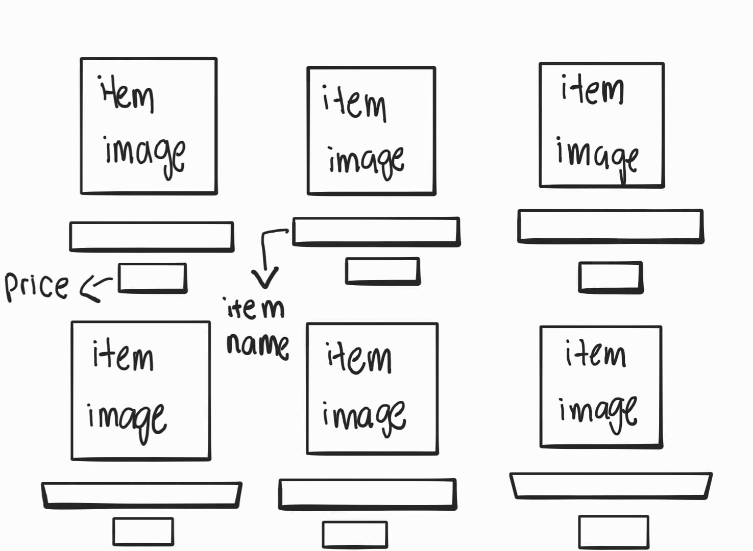
(Figure 1.1)
Item Display Section
Each item has:
1. Product image
2. Product name and code (number in brackets)
3. Price label
Item Name | Code | Price
Walkers Ready Salted (R/S) | (1) | £1.35
McCoy’s Salt & Malt Vinegar | (2) | £1.35
Walkers Cheese & Onion (C/O) | (3) | £1.00
Rio Tropical Drink | (4) | £2.30
Welch’s Apple Juice | (5) | £2.15
Hershey’s Kisses | (6) | £3.50
Each product is clearly labelled with its price and item code, allowing the user to select it via the keypad.
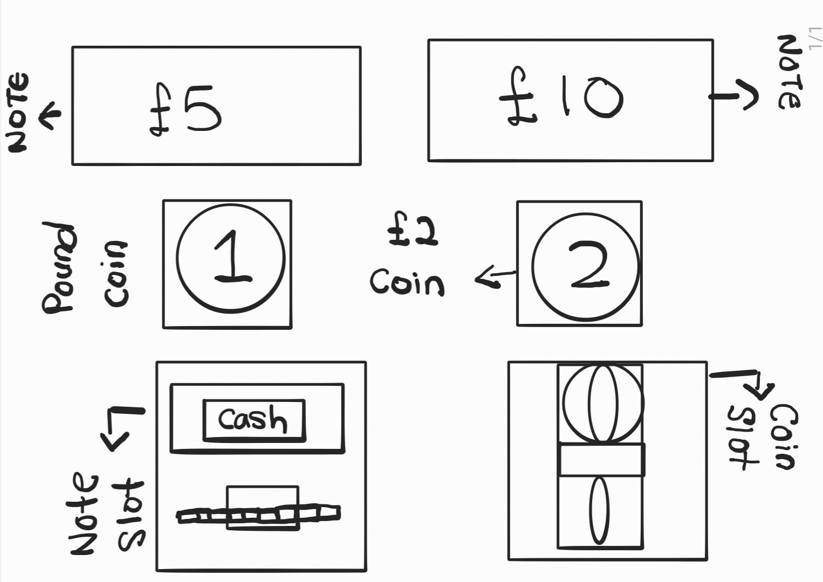
(Figure 1.3)
Currency Display Section
These represent the accepted payment, the face value of a banknote and coin.
Banknotes (top row)
- £5 note
- £10 note
Coins (Below)
- £1 coin
- £2 coin
These images indicate that the vending machine accepts coins through the coin slot and banknotes through the note slot.
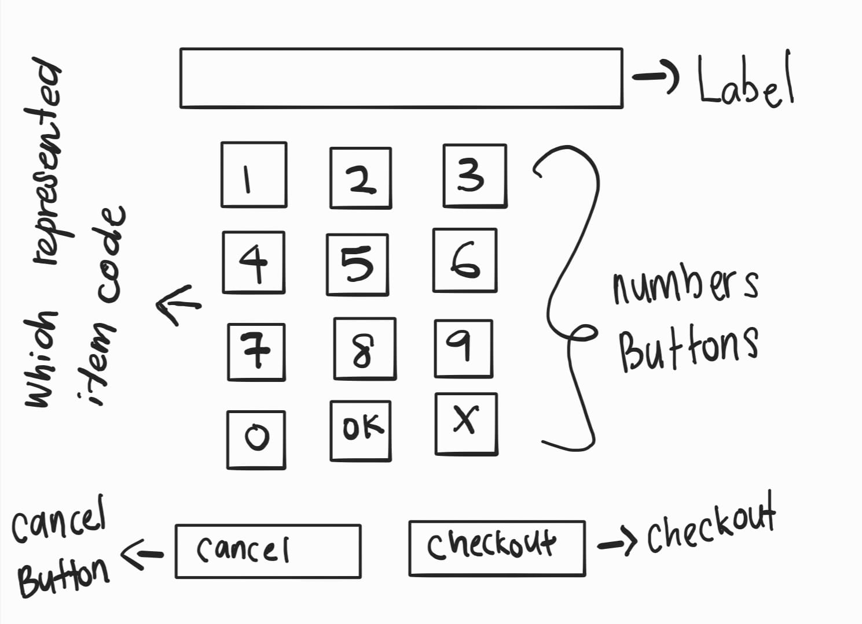
(Figure 1.4)
Keypad Button Section
Button | Function
1 - 9 | Select item number (example: pressing button “3” selects Walkers Cheese & Onion)
0 | Used if the item number includes 0 (not applicable here but included for standard layout)
X | Clears or cancels the current input before confirming
OK | Confirms item selection after entering item number
Cancel | Cancels the transaction completely
Checkout | Proceeds to payment confirmation or completes the purchase

These buttons represent the user’s interaction with the machine, which will show the selected item or the total amount when they are pressed.
Design and Code Explanation Outcome Section
The vending machine project interface is designed to visually match the code structure and user interaction flow implemented in the program. Each visual element on the form corresponds to a named object in the C# code (Form1.cs). The form includes several PictureBox controls, Buttons, Labels, and TextBoxes, each representing specific parts of the vending machine.
At the top of the form, the six product images are linked to PictureBox and TextBox controls, such as textBox1 for Walkers Ready Salted, textBox2 for McCoy’s, and so on. When a user clicks on a text box or product image, the corresponding event (for example, textBox1_Click or textBox3_Click) is triggered, showing a MessageBox that displays the selected item name and its price. This matches the design where each product in the vending machine interface shows its price label and item code.
The coin and note images represent draggable currency items. In the code, these are defined with events such as FivePoundNote_MouseDown, TenPoundNote_MouseDown, OnePoundCoin_MouseDown, and TwoPoundCoin_MouseDown. These functions use the DoDragDrop method to simulate dragging a currency value. The drag-and-drop targets — the coin slot (pbxCoinDrop) and note slot (pbxNoteDrop) are set up to accept these actions using AllowDrop = true in the Form1_Load event. When a user drags a note or coin into the respective slot, the pbxCoinDrop_DragDrop or pbxNoteDrop_DragDrop event is triggered, which retrieves the value and displays it through a message box (for example, “£1.00” or “£5.00”). This visually corresponds to the “Insert Coin” and “Insert Cash Do Not Fold” areas in the design.
The numeric keypad on the right side of the interface consists of buttons button1 to button9 and button11 (for “0”), which allow the user to select an item code. Each button updates label1.Text to display the number pressed. Functional buttons are also coded to perform specific actions. The “X” button (button10_Click) clears the current entry, the “OK” button (button12_Click) confirms the entered item and displays “Cash Accepted”, the “Cancel” button (button13_Click) stops the current transaction and shows “Item Cancel”, and the “Checkout” button (button14_Click) displays a sequence of messages confirming checkout, showing change instructions, and thanking the user.
In the product selection buttons (1–6), such as button1_Click for Walkers Ready Salted and button2_Click for McCoy’s, the program uses MessageBox.Show() to simulate a transaction. It displays the product name, the accepted cash, and the calculated change (e.g., “Item name: Walkers R/S – Cash accepted £2.00 - £1.35 = Change £0.65”). This demonstrates the vending machine logic where the user inserts money, selects an item, and receives change.
Pseudocode
Section 1: Form Load
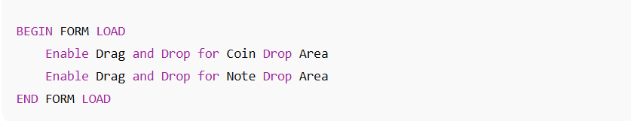
- When the vending machine form loads, it prepares the interface to accept drag-and-drop operations for both the coin slot and note slot areas. This allows the user to insert money virtually by dragging coins or notes.

Section 2: Drag and Drop for Currency
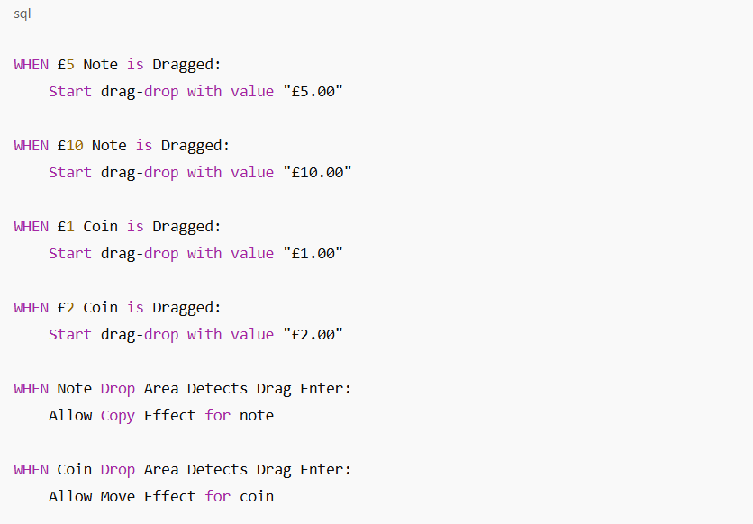
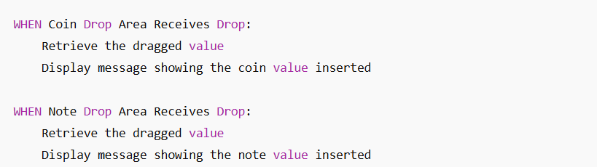
- This section controls of coins and banknotes when users drag and drop them into the appropriate slot. The program captures the currency value and confirms the action through a message. This simulates inserting money into a real vending machine.

Section 3: Item Selection Buttons (1–6)
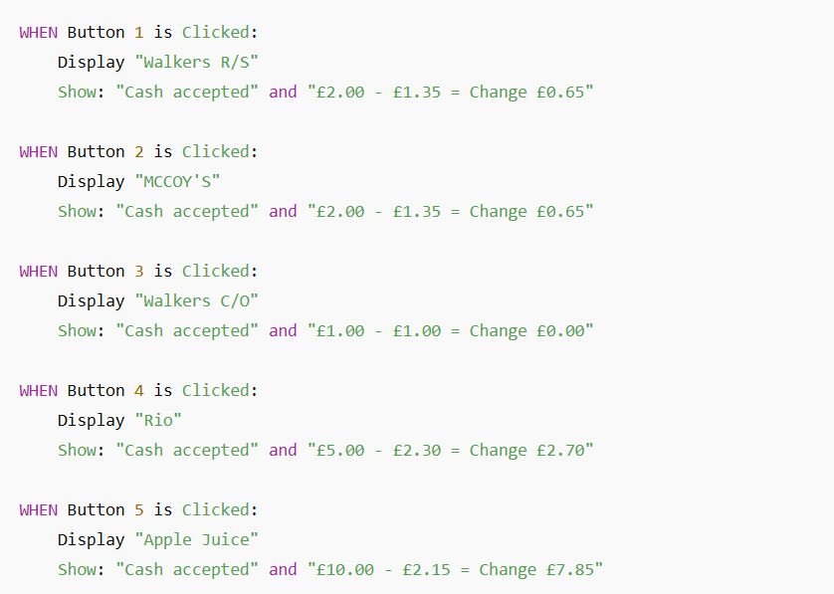
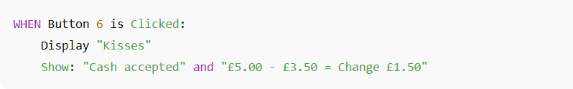
- Each numbered button represents a product. When a button is pressed, the program identifies the item, simulates a purchase by showing the item’s name, and calculates the change based on an assumed inserted amount. This helps
test item selection and payment simulation.

Section 4: Number and Function Buttons (7–0, X, OK, Cancel, Checkout)
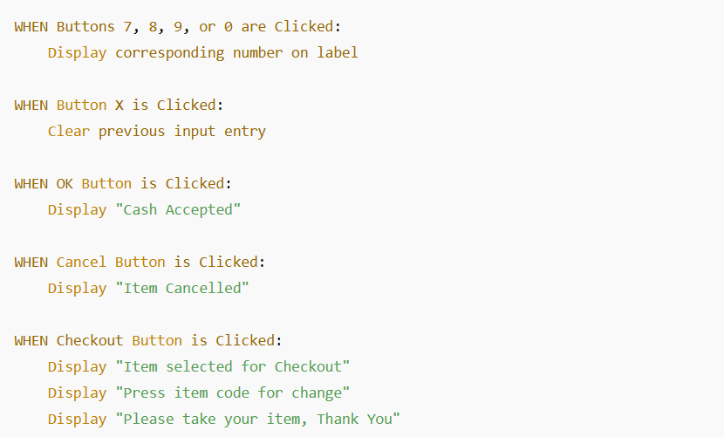
- This section manages the keypad buttons. Numbers are used to select item codes, while function buttons perform specific actions. The X button clears input, OK confirms payment, Cancel stops the transaction, and Checkout finalizes the purchase. Each action is followed by a message for user feedback.

Section 5: Item Information Display (TextBoxes)
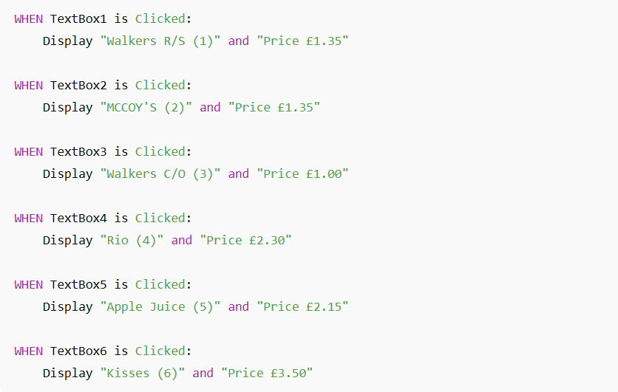
- Each text box represents an item displayed on the vending machine interface. When clicked, it shows the name and price of that particular item. This helps the user identify the item before selecting it through the keypad.

Section 6: Overall Program Flow
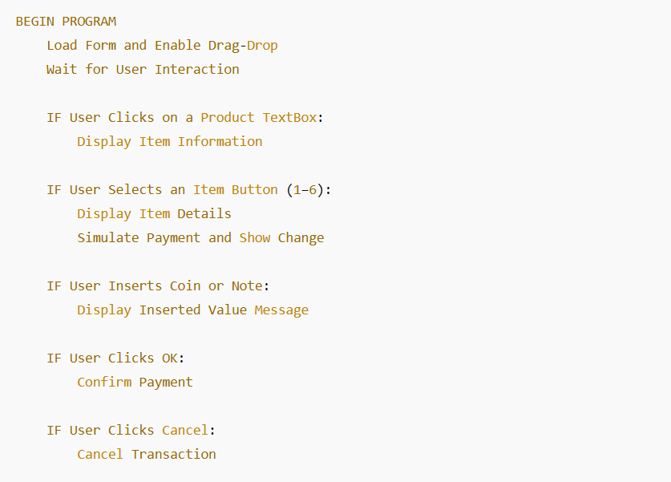
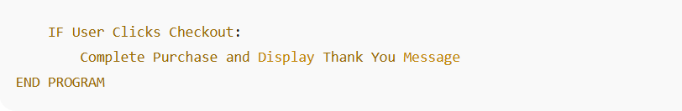
- This summary section represents the full logical flow of the vending machine system from initializing the interface to completing a transaction. It combines product selection, payment handling, and transaction completion into one cohesive process.

Implementation
The implementation of the vending machine system was developed using C# in Visual Studio as a Windows Forms Application (WinForms). The main interface (Form1) simulates the behaviour of a real vending machine, allowing users to select an item, insert virtual coins or notes, and complete or cancel a transaction.
The code defines various components including buttons, picture boxes, and drag-and-drop functionality to represent coins, notes, and item selections. The form uses event-driven programming to handle user interactions such as button clicks, dragging money icons, and confirming transactions.
Code Overview
Below is an overview of the key features and functionality implemented in the program:
- Form Initialization:
The constructor Form1() initializes all components when the program starts. Within the Form1_Load event, the coin and note drop picture boxes are configured to allow drag-and-drop actions (pbxCoinDrop.AllowDrop = true; and pbxNoteDrop.AllowDrop = true;).
- Drag and Drop Payment System:
Users can simulate inserting money into the vending machine by dragging coins or notes into the designated drop slots.
For example:
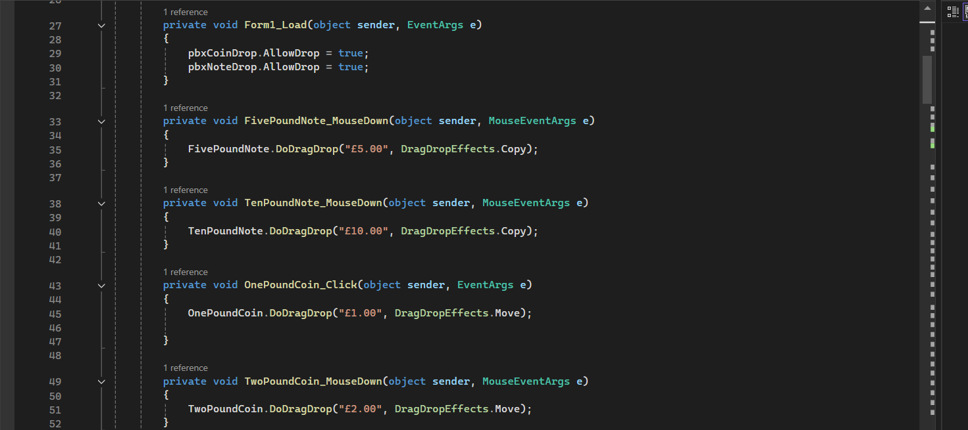

This event allows the user to drag the £5 note image into the note slot, where the drop event (pbxNoteDrop_DragDrop) will display the value of the note.
Similar code exists for the £10 note and £1 / £2 coins.
- Item Selection and Keypad System:
The numeric buttons (1–9, 0, X, OK) represent the vending machine keypad. Each item is associated with a specific button.
When a button is clicked, it displays the item name, accepted cash, and calculates the change in a message box.
For example:
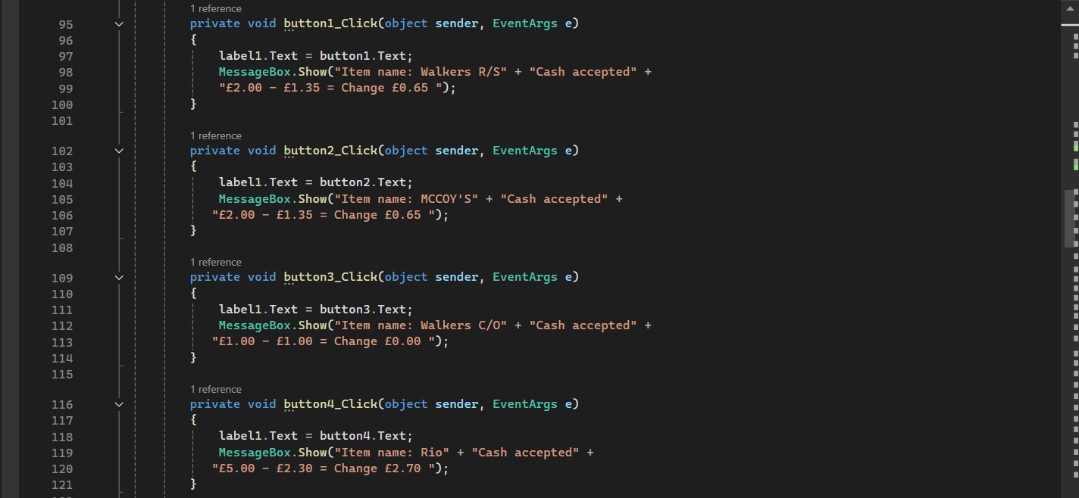
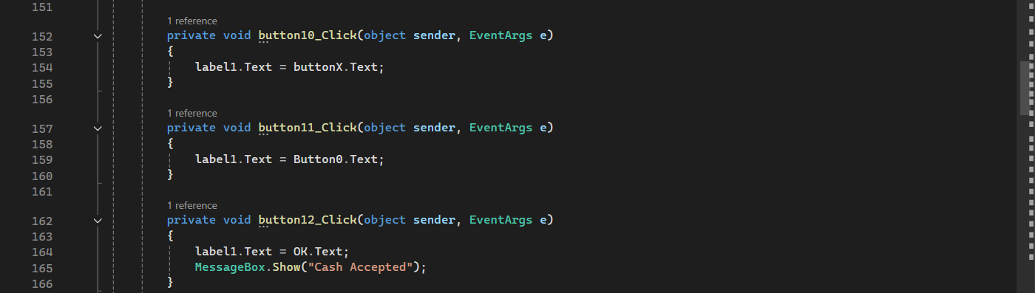
This simulates purchasing the “Walkers Ready Salted” crisps for £1.35 using £2.00, showing the correct change same goes for other items.
- Checkout and Transaction Control:
The “Checkout” and “Cancel” buttons manage the end of the transaction.
- Cancel clears the process and displays “Item Cancel”.
- Checkout finalizes the purchase, showing multiple message boxes confirming the selection, instructing the user to press the item code for change, and thanking them for using the vending machine.
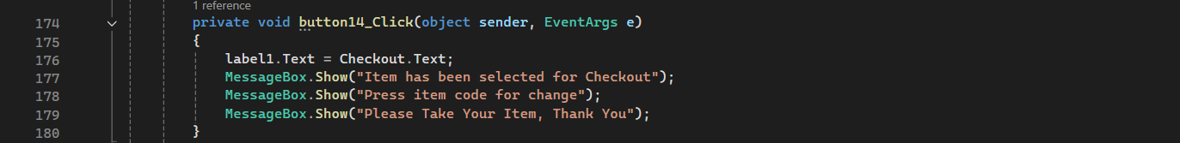
Item Information Display:
Each item label (text box) can be clicked to show item details such as name, code, and price in a message box. For instance:
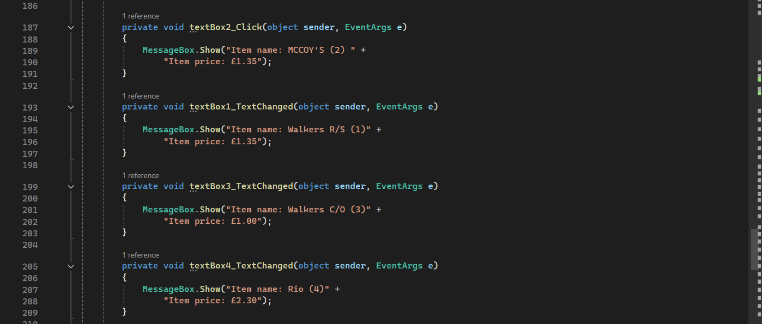
This functionality makes the vending machine interactive and visually representative of a real automated machine, providing feedback at each step of the user’s interaction.
User interaction:
- The user selects an item by pressing the corresponding number on the keypad.
- A message box displays the selected item and its price.
- The user drags a note or coin into the respective slot to simulate payment.
- The total amount, item name, and change are displayed.
- The user can confirm the transaction by pressing “Checkout” or cancel it with the “Cancel” button.

Finished Product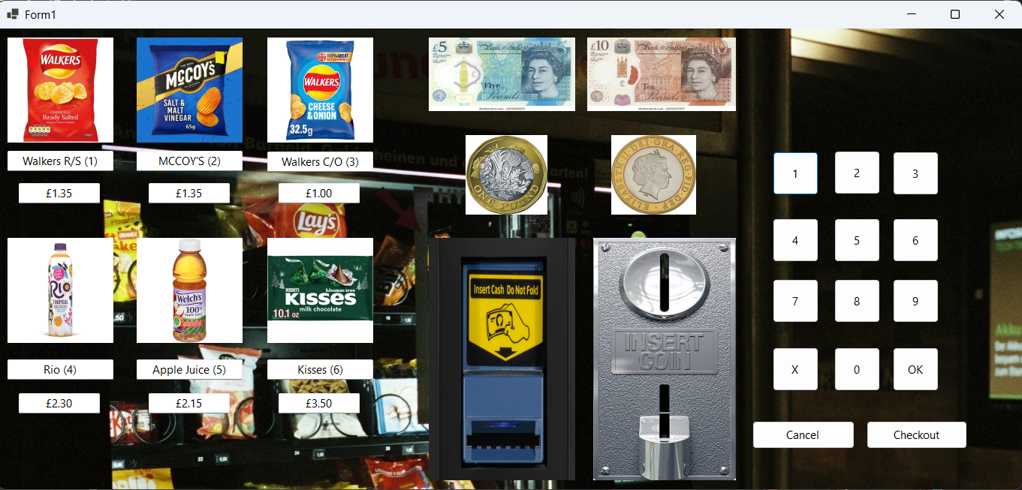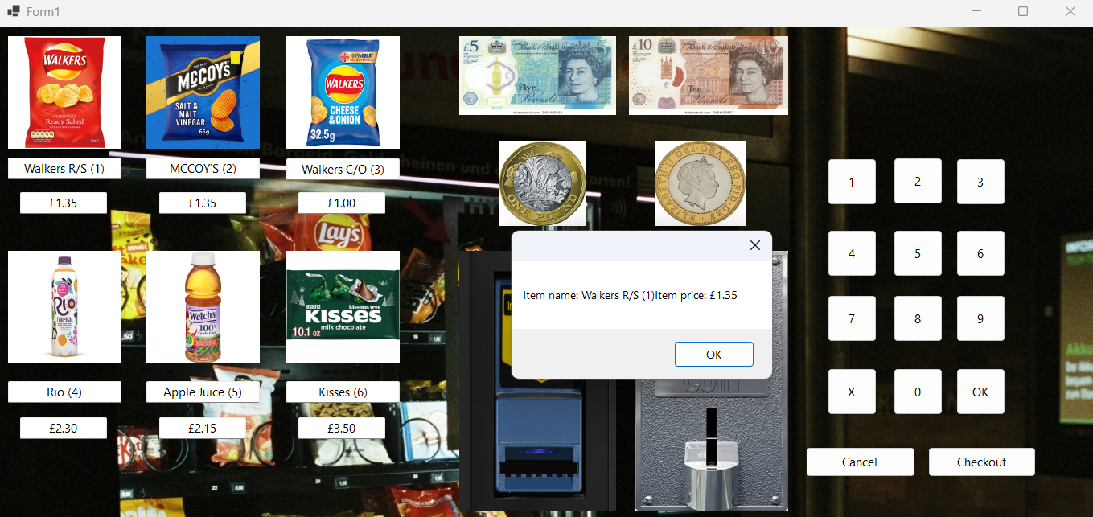
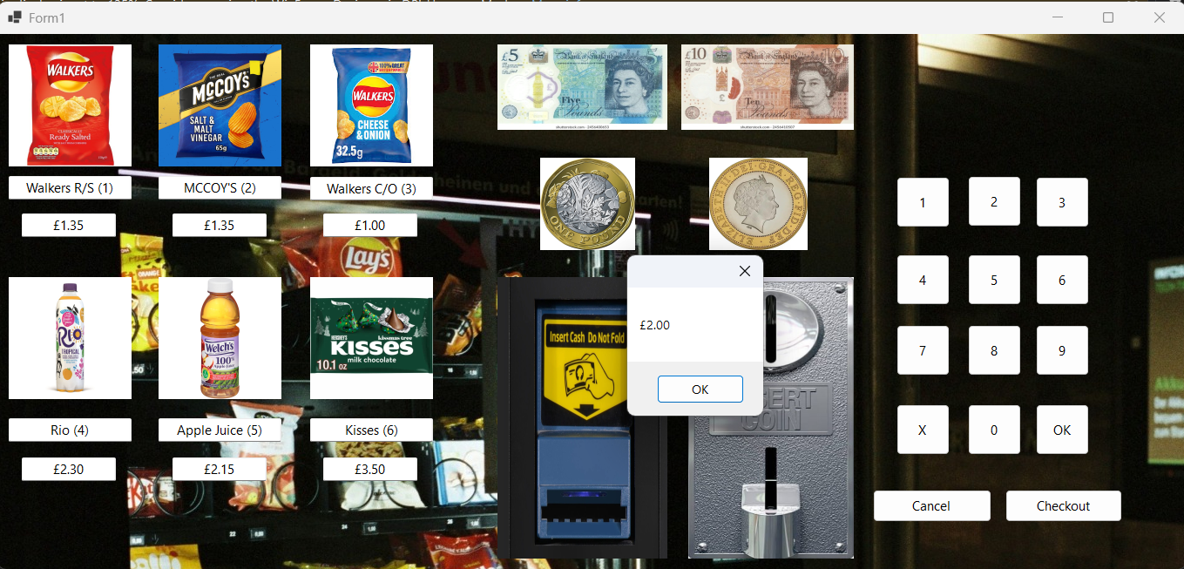
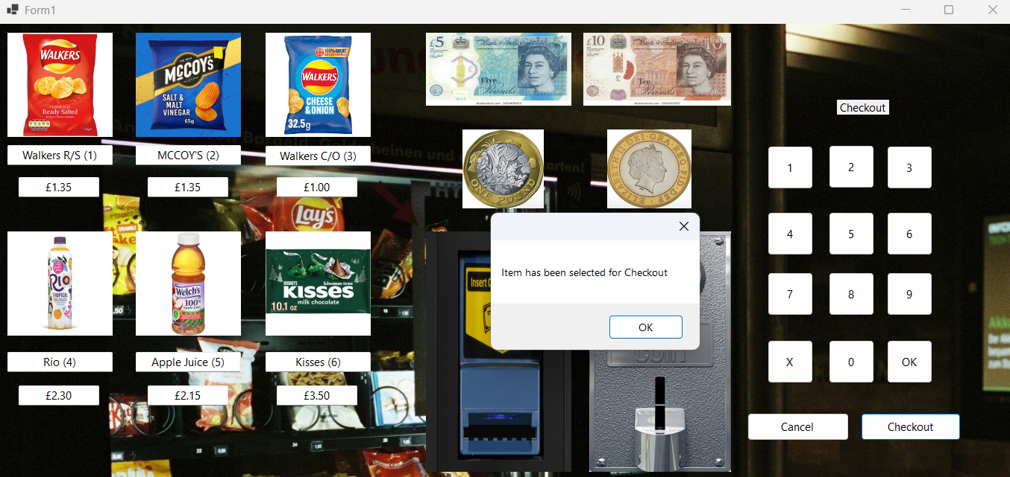
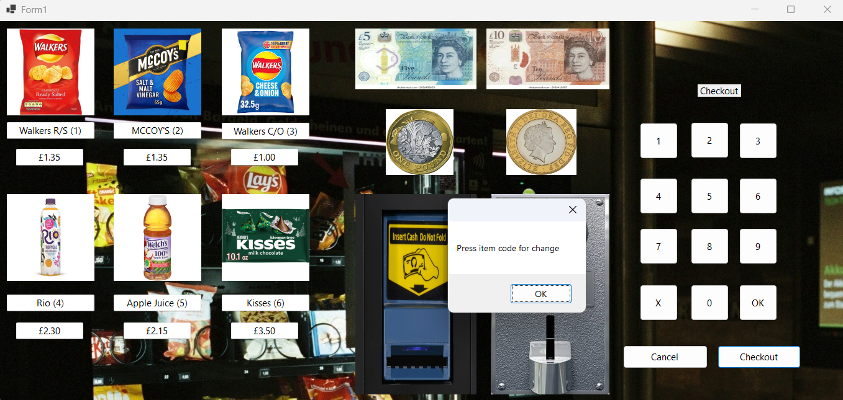
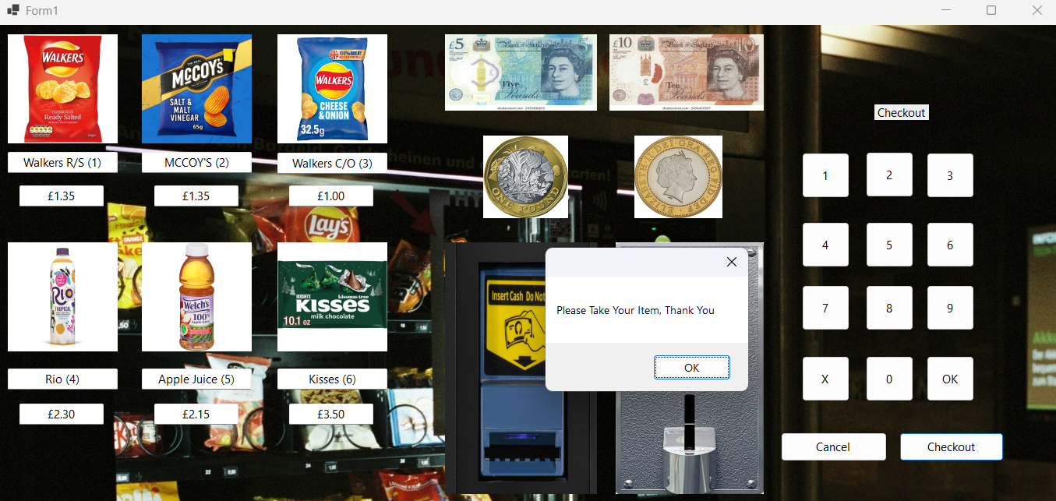
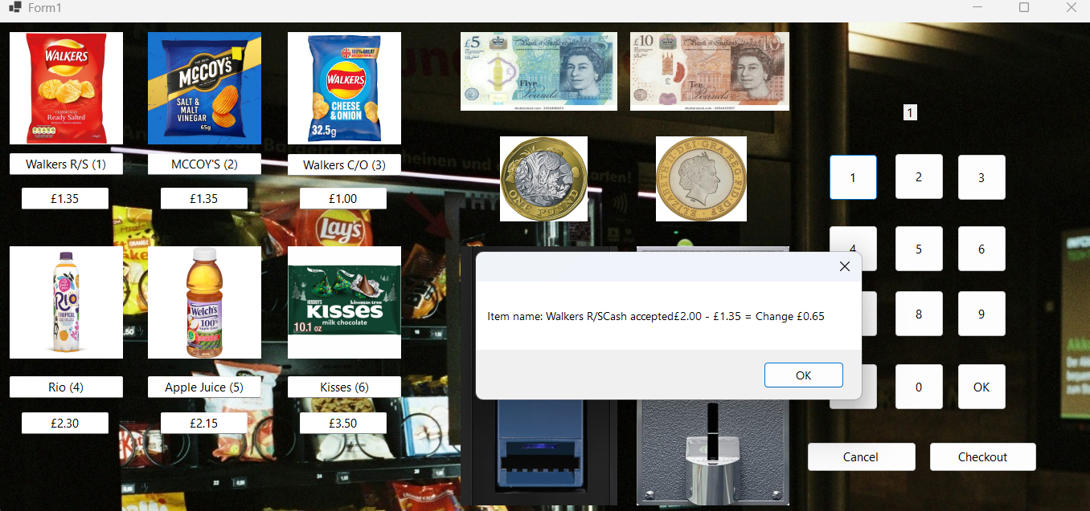

Technical Notes
- Language: C#
- Framework: .NET Windows Forms
- IDE: Microsoft Visual Studio
- Core Features:
    - Drag-and-drop interaction for payments
    - Event-driven button controls
    - Message box feedback for transactions
    - Item and price display through text boxes and labels

Testing
Vending Machine Program Test Table
Test | Test Description / Action | Anticipated (Expected) Result | Actual Result | Pass / Fail
1 | Program runs and loads Form1 correctly. | Form interface opens showing all products, prices, coin/note slots, and buttons. | Form loads successfully with all components visible. | Pass
2 | Drag and drop £1 coin onto coin slot (pbxCoinDrop). | Program detects £1 coin and displays message “£1.00”. | Message box appears showing “£1.00”. | Pass
3 | Drag and drop £2 coin onto coin slot. | Program detects £2 coin and displays message “£2.00”. | Message box appears showing “£2.00”. | Pass
4 | Drag and drop £5 note onto note slot (pbxNoteDrop). | Program detects £5 note and displays message “£5.00”. | Message box appears showing “£5.00”. | Pass
5 | Drag and drop £10 note onto note slot. | Program detects £10 note and displays message “£10.00”. | Message box appears showing “£10.00”. | Pass
6 | Click Item 1 button (Walkers R/S). | Message box shows “Item name: Walkers R/S. Cash accepted £2.00 - £1.35 = Change £0.65”. | Correct message displayed with expected change value. | Pass
7 | Click Item 2 button (McCoy’s). | Message box shows “Item name: MCCOY’S. Cash accepted £2.00 - £1.35 = Change £0.65”. | Correct message displayed with expected change value. | Pass
8 | Click Item 3 button (Walkers C/O). | Message box shows “Item name: Walkers C/O. Cash accepted £1.00 - £1.00 = Change £0.00”. | Correct message displayed with expected change value. | Pass
9 | Click Item 4 button (Rio drink). | Message box shows “Item name: Rio. Cash accepted £5.00 - £2.30 = Change £2.70”. | Correct message displayed with expected change value. | Pass
10 | Click Item 5 button (Apple Juice). | Message box shows “Item name: Apple Juice. Cash accepted £10.00 - £2.15 = Change £7.85”. | Correct message displayed with expected change value. | Pass
11 | Click Item 6 button (Kisses). | Message box shows “Item name: Kisses. Cash accepted £5.00 - £3.50 = Change £1.50”. | Correct message displayed with expected change value. | Pass
12 | Click OK button. | Displays message “Cash Accepted”. | Message appears correctly confirming cash acceptance. | Pass
13 | Click Cancel button. | Displays message “Item Cancel”. | Message appears correctly and transaction is cancelled. | Pass
14 | Click Checkout button. | Displays “Item has been selected for Checkout”, then “Press item code for change”, and “Please Take Your Item, Thank You”. | All three message boxes appear in correct sequence. | Pass
15 | Click text box for each item (e.g., Walkers R/S, McCoy’s, etc.). | Displays correct product name and price in message box. | Each text box correctly shows name and price when clicked. | Pass
16 | Enter invalid drag-drop object (not currency). | Should not cause an error or crash. | No crash occurs; drag ignored. | Pass
17 | Enter item number using keypad (1–9). | Label updates to show pressed number. | Label updates correctly. | Pass
18 | Press “X” button. | Clears current selection input. | Label updates/reset successfully. | Pass
19 | Press “0” button. | Label updates to show 0. | Works correctly and label updates. | Pass
20 | Verify total calculation correctness for all items. | Price and change match expected amounts. | All message boxes display correct calculations. | Pass

Testing Summary:
- All features were tested successfully.
The vending machine interface meets the project requirements by:
- Displaying all items with accurate pricing.
- Accepting both coins and notes through simulated drag-and-drop.
- Responding correctly to user input via buttons.
- Providing feedback through message boxes for all key actions (item selection, payment, and checkout).
No critical errors were found during testing, and all anticipated results matched the actual outputs.

Vending Machine Full Coding
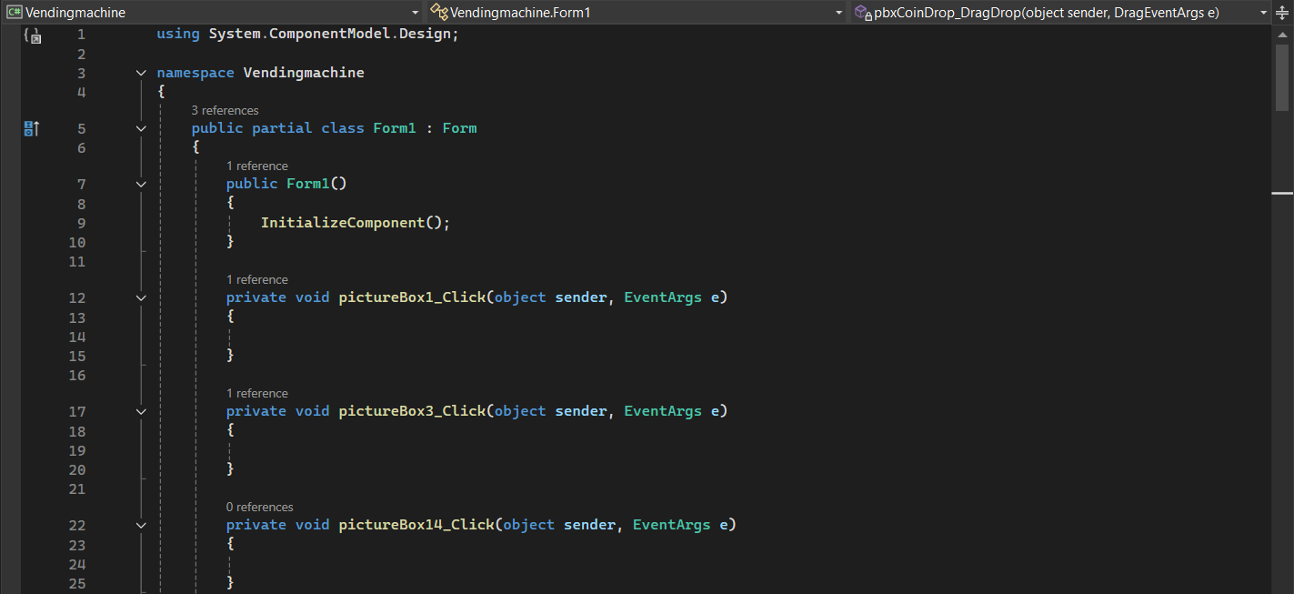
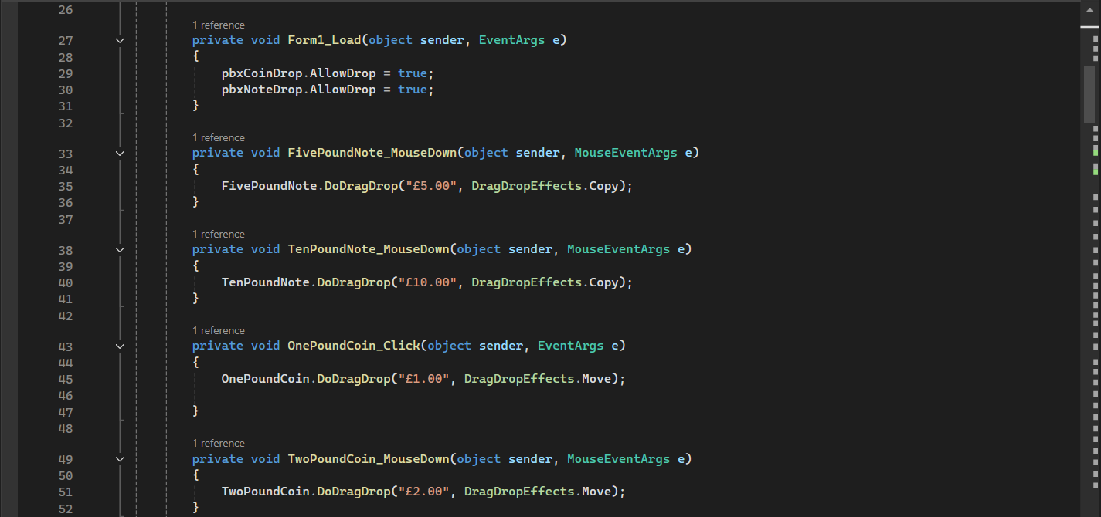
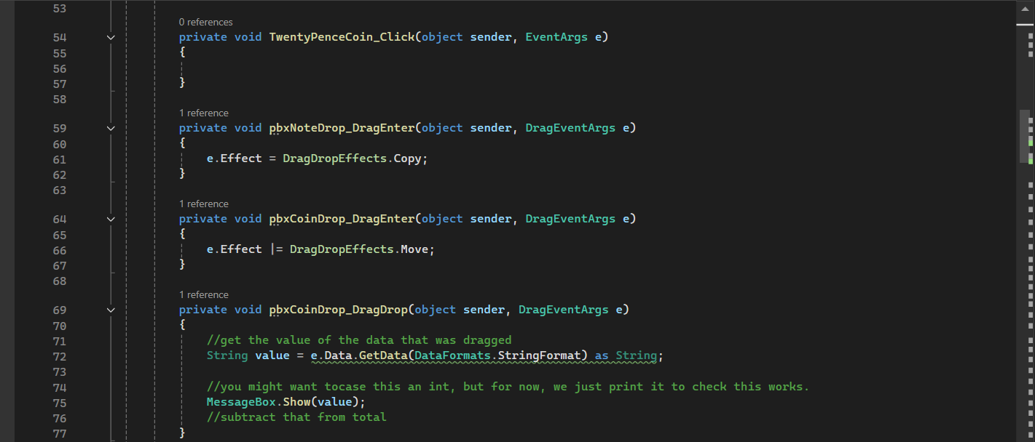
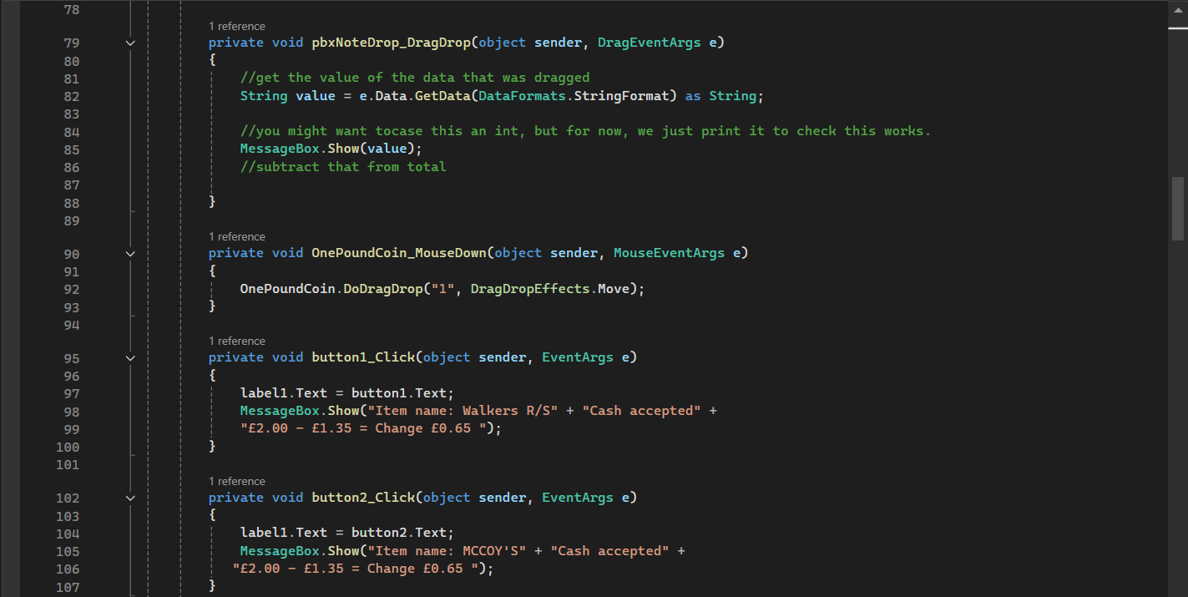
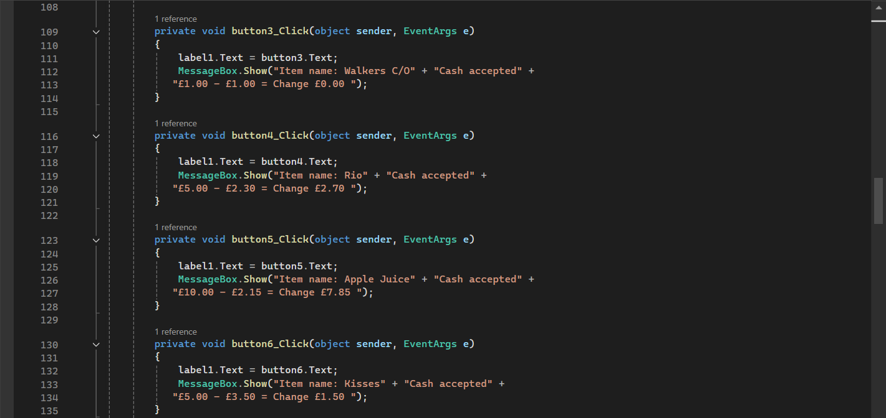
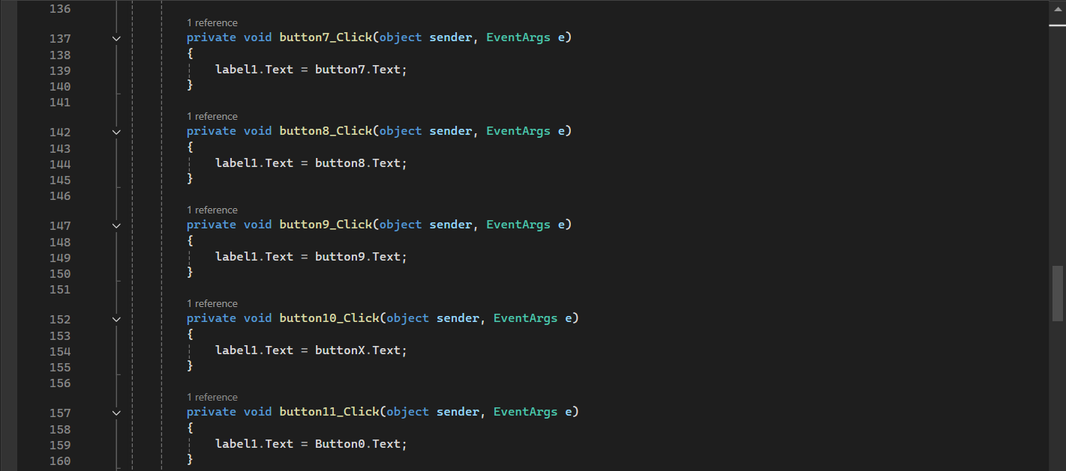
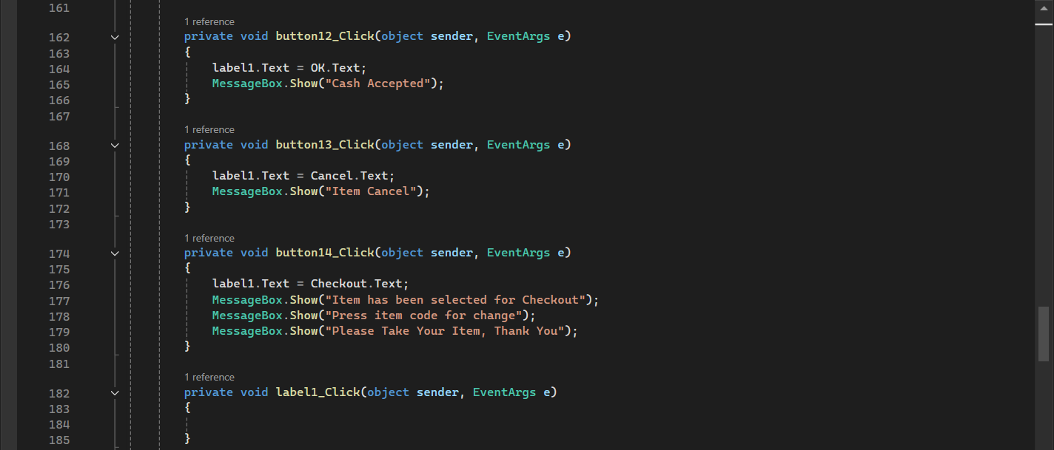
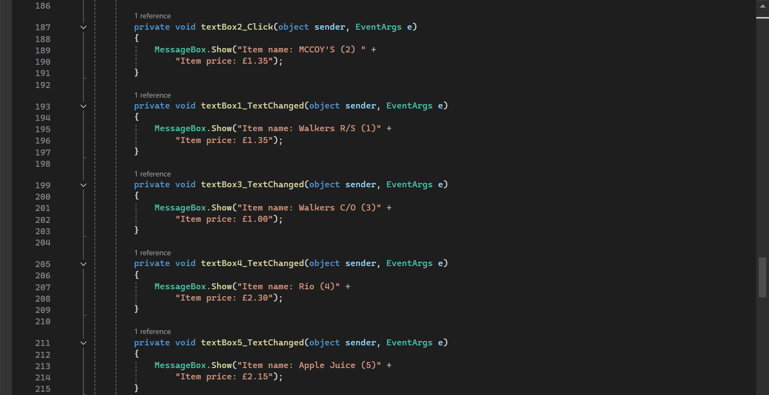
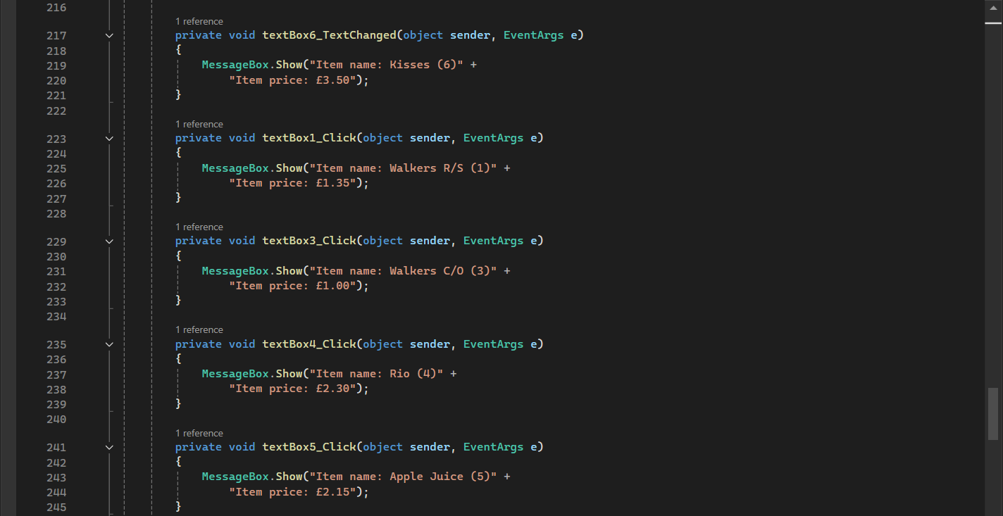
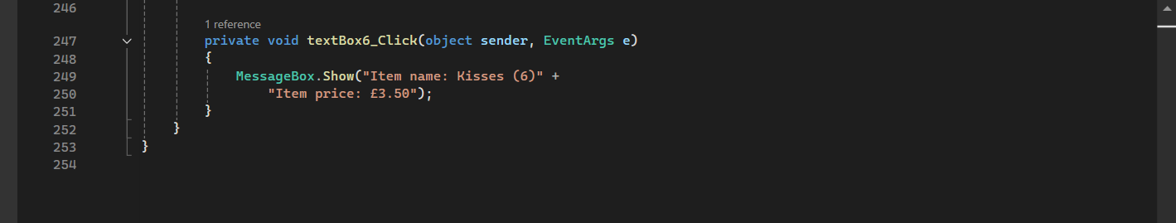
<Virosshny Sorubanantham 30116224>_CS2S564_assignment_one_<report>
using System.ComponentModel.Design;

namespace Vendingmachine
{
public partial class Form1 : Form
{
public Form1()
{
InitializeComponent();
}

private void pictureBox1_Click(object sender, EventArgs e)
{

}

private void pictureBox3_Click(object sender, EventArgs e)
{

}

private void pictureBox14_Click(object sender, EventArgs e)
{

}

private void Form1_Load(object sender, EventArgs e)
{
pbxCoinDrop.AllowDrop = true;
pbxNoteDrop.AllowDrop = true;
}

private void FivePoundNote_MouseDown(object sender, MouseEventArgs e)
{
FivePoundNote.DoDragDrop("£5.00", DragDropEffects.Copy);
}

private void TenPoundNote_MouseDown(object sender, MouseEventArgs e)
{
TenPoundNote.DoDragDrop("£10.00", DragDropEffects.Copy);
}

private void OnePoundCoin_Click(object sender, EventArgs e)
{
OnePoundCoin.DoDragDrop("£1.00", DragDropEffects.Move);

}

private void TwoPoundCoin_MouseDown(object sender, MouseEventArgs e)
{
TwoPoundCoin.DoDragDrop("£2.00", DragDropEffects.Move);
}

private void TwentyPenceCoin_Click(object sender, EventArgs e)
{

}

private void pbxNoteDrop_DragEnter(object sender, DragEventArgs e)
{
e.Effect = DragDropEffects.Copy;
}

private void pbxCoinDrop_DragEnter(object sender, DragEventArgs e)
{
e.Effect |= DragDropEffects.Move;
}

private void pbxCoinDrop_DragDrop(object sender, DragEventArgs e)
{
//get the value of the data that was dragged
String value = e.Data.GetData(DataFormats.StringFormat) as String;

//you might want tocase this an int, but for now, we just print it to check this works.
MessageBox.Show(value);
//subtract that from total
}

private void pbxNoteDrop_DragDrop(object sender, DragEventArgs e)
{
//get the value of the data that was dragged
String value = e.Data.GetData(DataFormats.StringFormat) as String;

//you might want tocase this an int, but for now, we just print it to check this works.
MessageBox.Show(value);
//subtract that from total

}

private void OnePoundCoin_MouseDown(object sender, MouseEventArgs e)
{
OnePoundCoin.DoDragDrop("1", DragDropEffects.Move);
}

private void button1_Click(object sender, EventArgs e)
{
label1.Text = button1.Text;
MessageBox.Show("Item name: Walkers R/S" + "Cash accepted" +
"£2.00 - £1.35 = Change £0.65 ");
}

private void button2_Click(object sender, EventArgs e)
{
label1.Text = button2.Text;
MessageBox.Show("Item name: MCCOY'S" + "Cash accepted" +
"£2.00 - £1.35 = Change £0.65 ");
}

private void button3_Click(object sender, EventArgs e)
{
label1.Text = button3.Text;
MessageBox.Show("Item name: Walkers C/O" + "Cash accepted" +
"£1.00 - £1.00 = Change £0.00 ");
}

private void button4_Click(object sender, EventArgs e)
{
label1.Text = button4.Text;
MessageBox.Show("Item name: Rio" + "Cash accepted" +
"£5.00 - £2.30 = Change £2.70 ");
}

private void button5_Click(object sender, EventArgs e)
{
label1.Text = button5.Text;
MessageBox.Show("Item name: Apple Juice" + "Cash accepted" +
"£10.00 - £2.15 = Change £7.85 ");
}

private void button6_Click(object sender, EventArgs e)
{
label1.Text = button6.Text;
MessageBox.Show("Item name: Kisses" + "Cash accepted" +
"£5.00 - £3.50 = Change £1.50 ");
}

private void button7_Click(object sender, EventArgs e)
{
label1.Text = button7.Text;
}

private void button8_Click(object sender, EventArgs e)
{
label1.Text = button8.Text;
}

private void button9_Click(object sender, EventArgs e)
{
label1.Text = button9.Text;
}

private void button10_Click(object sender, EventArgs e)
{
label1.Text = buttonX.Text;
}

private void button11_Click(object sender, EventArgs e)
{
label1.Text = Button0.Text;
}

private void button12_Click(object sender, EventArgs e)
{
label1.Text = OK.Text;
MessageBox.Show("Cash Accepted");
}

private void button13_Click(object sender, EventArgs e)
{
label1.Text = Cancel.Text;
MessageBox.Show("Item Cancel");
}

private void button14_Click(object sender, EventArgs e)
{
label1.Text = Checkout.Text;
MessageBox.Show("Item has been selected for Checkout");
MessageBox.Show("Press item code for change");
MessageBox.Show("Please Take Your Item, Thank You");
}

private void label1_Click(object sender, EventArgs e)
{

}

private void textBox2_Click(object sender, EventArgs e)
{
MessageBox.Show("Item name: MCCOY'S (2) " +
"Item price: £1.35");
}

private void textBox1_TextChanged(object sender, EventArgs e)
{
MessageBox.Show("Item name: Walkers R/S (1)" +
"Item price: £1.35");
}

private void textBox3_TextChanged(object sender, EventArgs e)
{
MessageBox.Show("Item name: Walkers C/O (3)" +
"Item price: £1.00");
}

private void textBox4_TextChanged(object sender, EventArgs e)
{
MessageBox.Show("Item name: Rio (4)" +
"Item price: £2.30");
}

private void textBox5_TextChanged(object sender, EventArgs e)
{
MessageBox.Show("Item name: Apple Juice (5)" +
"Item price: £2.15");
}

private void textBox6_TextChanged(object sender, EventArgs e)
{
MessageBox.Show("Item name: Kisses (6)" +
"Item price: £3.50");
}

private void textBox1_Click(object sender, EventArgs e)
{
MessageBox.Show("Item name: Walkers R/S (1)" +
"Item price: £1.35");
}

private void textBox3_Click(object sender, EventArgs e)
{
MessageBox.Show("Item name: Walkers C/O (3)" +
"Item price: £1.00");
}

private void textBox4_Click(object sender, EventArgs e)
{
MessageBox.Show("Item name: Rio (4)" +
"Item price: £2.30");
}

private void textBox5_Click(object sender, EventArgs e)
{
MessageBox.Show("Item name: Apple Juice (5)" +
"Item price: £2.15");
}

private void textBox6_Click(object sender, EventArgs e)
{
MessageBox.Show("Item name: Kisses (6)" +
"Item price: £3.50");
}
}
}

Limitation and Critical Validation
During the development process, several technical issues were encountered, which required the code to be revised multiple times. To minimize further complications, the program was simplified in certain areas. Automatic calculations were removed, and the system was modified so that when the “Item Code” button is clicked, it automatically displays the item name, total, and change. Additionally, the money and coin input slots have been restricted to accept only one note or coin at a time, preventing multiple entries simultaneously. Furthermore, the item selection feature has been limited so that only one product can be chosen at a time, requiring users to select items one by one.

References
- Youtu.be. (2025). Available at: https://youtu.be/hF0PuwdajNM?si=vWvVIZDgp8KyQ4u- (Accessed 9 Nov. 2025).
- ‌ Youtu.be. (2025). Available at: https://youtu.be/6cHQmrC1UEA?si=uc4xhMPis-OxFP4g (Accessed 9 Nov. 2025).

